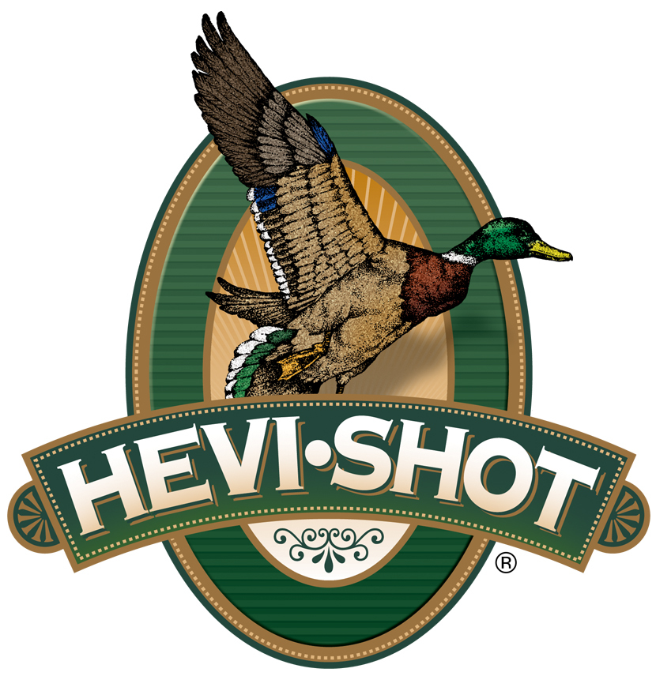

FOR IMMEDIATE RELEASE
HEVI-Shot’s New HEVI-Hammer 12-Gauge BB Load Now Shipping
SWEET HOME, Oregon – October 15, 2025 – HEVI-Shot is now shipping a new 12-gauge 3-inch option in BB shot within its HEVI-Hammer waterfowl ammunition line. This lineup of loads includes a variety of BB-, 2-, and 3-shot offerings in both 25-count and 100-count pack sizes. The newest option is the Hevi-Hammer, 12 Gauge, BB shot, 3-inch, 1 1/4-ounce, 1,500 fps, and is currently available at retailers nationwide.
HEVI-Hammer | Hevi Shot
“This new HEVI-Hammer 12-gauge load gives hunters more options to match their ammo with their hunt,” said Scott Turner, HEVI-Shot’s Shotshell Product Manager. “By layering our cast HEVI-Bismuth pellets over precision steel, we’re able to boost pattern performance and extend effective range—so you can take home more birds at longer distances.”
HEVI-Hammer blends performance and affordability by combining 15 percent of HEVI-Bismuth—a dense, 9.6 g/cc pellet alloyed and cast in Sweet Home, Oregon—with 85 percent precision steel shot. The resulting payload offers 38 to 41 percent more lethal range than steel alone. The bismuth layer sits atop the shot column for tighter patterns, deeper penetration, and more clean kills, especially in cold-weather conditions.
Part No. / Description / MSRP
HS28088 / HEVI-Hammer, 12 Ga, 3-inch, BB, 1 ¼ ounce, 25-count box / $39.99
HEVI-Shot products are available at dealers nationwide and online. For more information on all HEVI-Shot products and to sign up for product news, alerts, and promotions, visit www.hevishot.com.

Press Release Contact:
JJ Reich
Senior Manager – Press Relations
E-mail: media@tkghunt.com
About HEVI-Shot
Established in 2000 and based out of Sweet Home, Oregon, HEVI-Shot is a brand of The Kinetic Group, owned by CSG, a globally diversified industrial group based in Prague (Czech Republic). HEVI-Shot is an industry leader in performance shotshell, providing the next generation of shotshell loads to hunters—with their large and impressive selection of hunting ammunition options. HEVI-Shot is synonymous with high performance projectiles. The company meticulously designs each product to outperform any ammunition competitor in its class. That is why HEVI-Shot is the ammunition choice for serious hunters who live by their slogan: “I DIDN’T COME THIS FAR TO MISS!”

